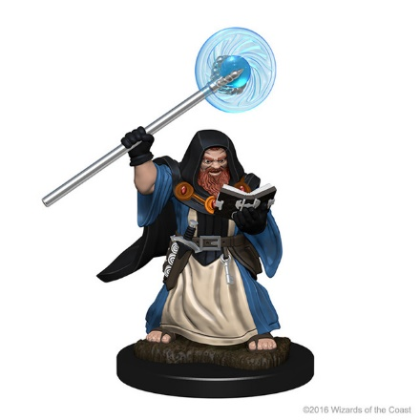
Bevret Blackrock
Male Dwarf
Attack: +6
Saving Throws: +3 (+6 INT and WIS)
Skill Checks: +3 (+6 Arcana and Insight)
Spell Save DC: 13 (3rd), 14 (5th), 15 (7th)
Health: ⃝ ⃝ ⃝ ⃝ ⃝ ⃝ ⃝

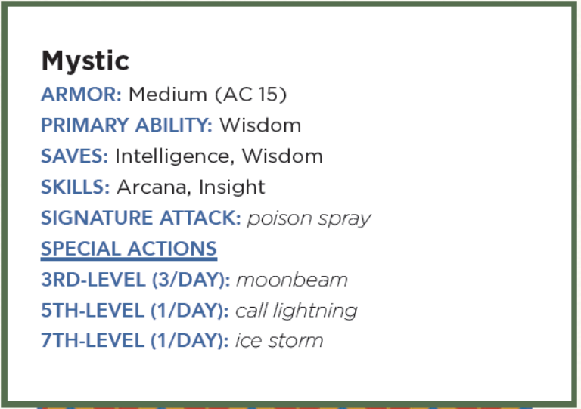
Poison Spray
cantrip conjuration
Casting Time: 1 action
Range: 10 feet
Components: V S
Duration: Instantaneous

You extend your hand toward a creature you can see within range and project a puff of noxious gas from your palm. The creature must succeed on a Constitution saving throw or take 1d12 poison damage.

Moonbeam
2nd Level evocation
Casting Time: 1 action
Range: 120 feet
Components: V S M (Several seeds of any moonseed plant and a piece of opalescent feldspar)
Duration: Up to 1 minute

A silvery beam of pale light shines down in a 5-foot-radius, 40-foot-high cylinder centered on a point within range. Until the spell ends, dim light fills the cylinder.
When a creature enters the spell’s area for the first time on a turn or starts its turn there, it is engulfed in ghostly flames that cause searing pain, and it must make a Constitution saving throw. It takes 2d10 radiant damage on a failed save, or half as much damage on a successful one.
A shape-changer makes its saving throw with disadvantage. If it fails, it also instantly reverts to its original form and can’t assume a different form until it leaves the spell’s light.
On each of your turns after you cast this spell, you can use an action to move the beam 60 feet in any direction.
At Higher Levels. When you cast this spell using a spell slot of 3rd level or higher, the damage increases by 1d10 for each slot level above 2nd.

Call Lightning
3rd Level conjuration
Casting Time: 1 action
Range: 120 feet
Components: V S
Duration: Up to 10 minutes

A storm cloud appears in the shape of a cylinder that is 10 feet tall with a 60-foot radius, centered on a point you can see 100 feet directly above you. The spell fails if you can’t see a point in the air where the storm cloud could appear (for example, if you are in a room that can’t accommodate the cloud). When you cast the spell, choose a point you can see within range. A bolt of lightning flashes down from the cloud to that point. Each creature within 5 feet of that point must make a Dexterity saving throw. A creature takes 3d10 lightning damage on a failed save, or half as much damage on a successful one. On each of your turns until the spell ends, you can use your action to call down lightning in this way again, targeting the same point or a different one. If you are outdoors in stormy conditions when you cast this spell, the spell gives you control over the existing storm instead of creating a new one. Under such conditions, the spell’s damage increases by 1d10.
At Higher Levels: When you cast this spell using a spell slot of 4th level or higher level, the damage increases by 1d10 for each slot level above 3rd.

Ice Storm
4 evocation
Casting Time: 1 action
Range: 300 feet
Components: V S M (A pinch of dust and a few drops of water)
Duration: Instantaneous

A hail of rock-hard ice pounds to the ground in a 20-foot-radius, 40-foot-high cylinder centered on a point within range. Each creature in the cylinder must make a Dexterity saving throw. A creature takes 2d8 bludgeoning damage and 4d6 cold damage on a failed save, or half as much damage on a successful one. Hailstones turn the storm’s area of effect into difficult terrain until the end of your next turn.
At Higher Levels: When you cast this spell using a spell slot of 5th level or higher, the bludgeoning damage increases by 1d8 for each slot level above 4th.

Hunter's Mark
1 divination
Casting Time: 1 bonus action
Range: 90 feet
Components: V
Duration: Up to 1 hour

You choose a creature you can see within range and mystically mark it as your quarry. Until the spell ends, you deal an extra 1d6 damage to the target whenever you hit it with a weapon attack, and you have advantage on any Wisdom (Perception) or Wisdom (Survival) check you make to find it. If the target drops to 0 hit points before this spell ends, you can use a bonus action on a subsequent turn of yours to mark a new creature.
At Higher Levels: When you cast this spell using a spell slot of 3rd or 4th level, you can maintain your Concentration on the spell for up to 8 hours. When you use a spell slot of 5th level or higher, you can maintain your concentration on the spell for up to 24 hours.


Misaka
Female Half-Elf
Attack: +6
Saving Throws: +3 (+6 STR and DEX)
Skill Checks: +3 (+6 Acrobatics and Athletics)
Health: ⃝ ⃝ ⃝ ⃝ ⃝ ⃝ ⃝

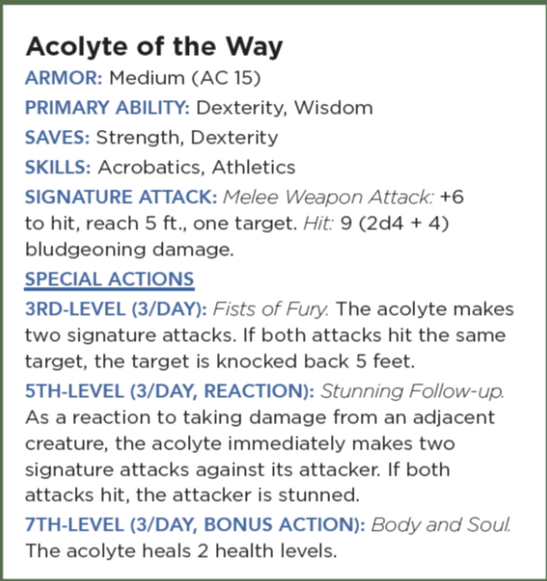

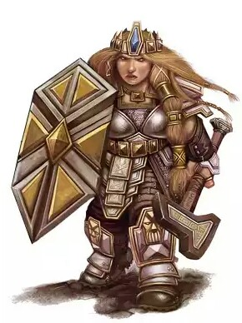

Vistra Steelbreaker
Female Dwarf
Attack: +6
Saving Throws: +3 (+6 INT and WIS)
Skill Checks: +3 (+6 Arcana and Insight)
Spell Save DC: 13 (3rd), 14 (5th), 15 (7th)
Health: ⃝ ⃝ ⃝ ⃝ ⃝ ⃝ ⃝

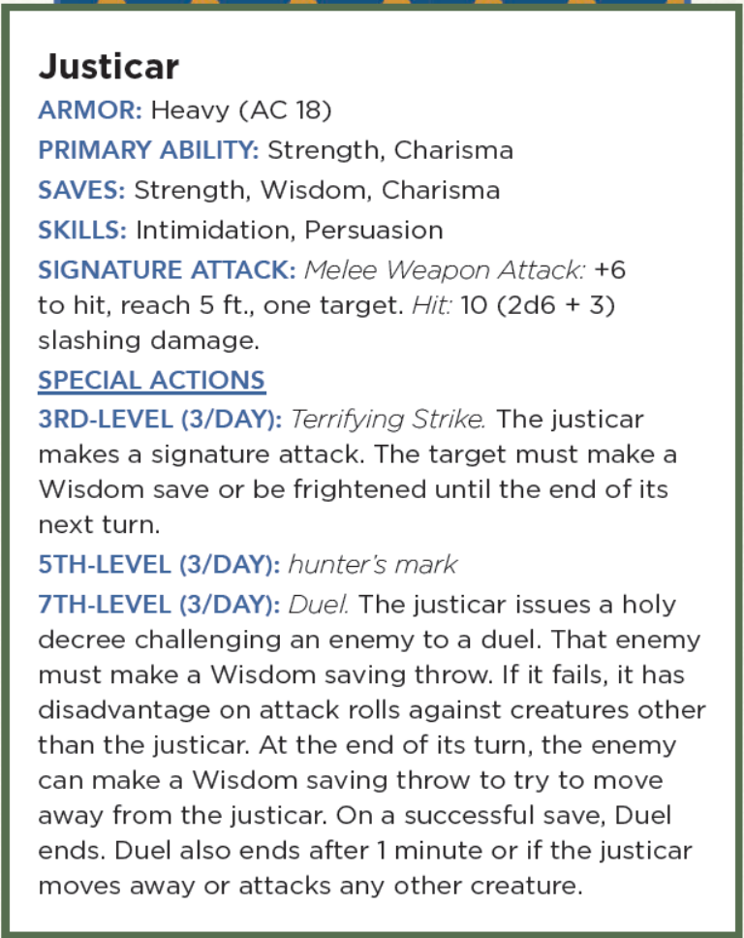


Buppido
Male Derro
Attack: +6
Saving Throws: +3 (+6 WIS and CHA)
Skill Checks: +3 (+6 Deception and Intimidation)
Spell Save DC: 13 (3rd), 14 (5th), 15 (7th)
Health: ⃝ ⃝ ⃝ ⃝ ⃝ ⃝ ⃝

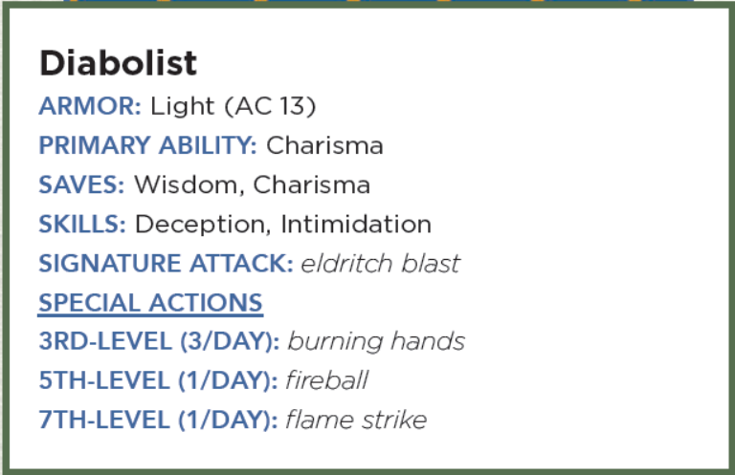

Eldritch Blast
cantrip evocation
Casting Time: 1 action
Range: 120 feet
Components: V S
Duration: Instantaneous

A beam of crackling energy streaks toward a creature within range. Make a ranged spell attack against the target. On a hit, the target takes 1d10 force damage.
The spell creates more than one beam when you reach higher levels: two beams at 5th level, three beams at 11th level, and four beams at 17th level. You can direct the beams at the same target or at different ones. Make a separate attack roll for each beam.

Burning Hands
1st Level evocation
Casting Time: 1 action
Range: Self (15-foot cone)
Components: V S
Duration: Instantaneous

As you hold your hands with thumbs touching and fingers spread, a thin sheet of flames shoots forth from your outstretched fingertips. Each creature in a 15-foot cone must make a Dexterity saving throw. A creature takes 3d6 fire damage on a failed save, or half as much damage on a successful one. The fire ignites any flammable objects in the area that aren’t being worn or carried.
At Higher Levels: When you cast this spell using a spell slot of 2nd level or higher, the damage increases by 1d6 for each slot level above 1st.

Fireball
3rd Level evocation
Casting Time: 1 action
Range: 150 feet
Components: V S M (A tiny ball of bat guano and sulfur)
Duration: Instantaneous

A bright streak flashes from your pointing finger to a point you choose within range and then blossoms with a low roar into an explosion of flame. Each creature in a 20-foot-radius sphere centered on that point must make a Dexterity saving throw. A target takes 8d6 fire damage on a failed save, or half as much damage on a successful one. The fire spreads around corners. It ignites flammable objects in the area that aren’t being worn or carried.
At Higher Levels: When you cast this spell using a spell slot of 4th level or higher, the damage increases by 1d6 for each slot level above 3rd.

Flame Strike
5th Level evocation
Casting Time: 1 action
Range: 60 feet
Components: V S M (Pinch of sulfur)
Duration: Instantaneous

A vertical column of divine fire roars down from the heavens in a location you specify. Each creature in a 10-foot-radius, 40-foot-high cylinder centered on a point within range must make a Dexterity saving throw. A creature takes 4d6 fire damage and 4d6 radiant damage on a failed save, or half as much damage on a successful one.
At Higher Levels: When you cast this spell using a spell slot of 6th level or higher, the fire damage or the radiant damage (your choice) increases by 1d6 for each slot level above 5th.

Radelia Ravanala
Female Half-Elf
Attack: +6
Saving Throws: +3 (+6 WIS)
Skill Checks: +3 (+6 History and Medicine)
Spell Save DC: 13 (3rd), 14 (5th), 15 (7th)
Health: ⃝ ⃝ ⃝ ⃝ ⃝ ⃝ ⃝

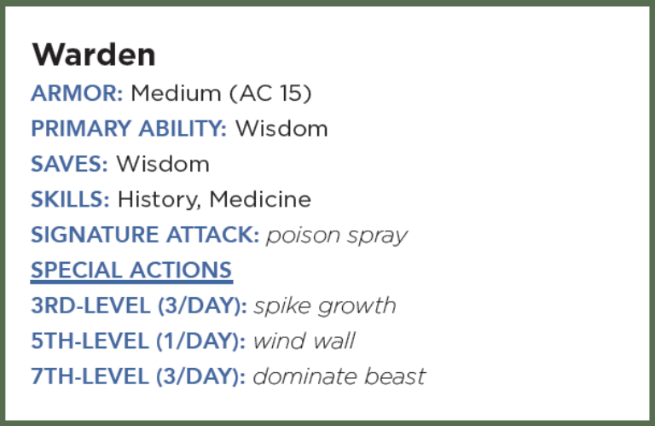

Poison Spray
cantrip conjuration
Casting Time: 1 action
Range: 10 feet
Components: V S
Duration: Instantaneous

You extend your hand toward a creature you can see within range and project a puff of noxious gas from your palm. The creature must succeed on a Constitution saving throw or take 1d12 poison damage.

Spike Growth
2nd Level transmutation
Casting Time: 1 action
Range: 150 feet
Components: V S M (Seven sharp thorns or seven small twigs, each sharpened to a point)
Duration: Up to 10 minutes

The ground in a 20-foot radius centered on a point within range twists and sprouts hard spikes and thorns. The area becomes difficult terrain for the duration. When a creature moves into or within the area, it takes 2d4 piercing damage for every 5 feet it travels.
The transformation of the ground is camouflaged to look natural. Any creature that can’t see the area at the time the spell is cast must make a Wisdom (Perception) check against your spell save DC to recognize the terrain as hazardous before entering it.

Wind Wall
3rd Level evocation
Casting Time: 1 action
Range: 120 feet
Components: V S M (A tiny fan and a feather of exotic origin)
Duration: Up to 1 minute, Concentration

A wall of strong wind rises from the ground at a point you choose within range. You can make the wall up to 50 feet long, 15 feet high, and 1 foot thick. You can shape the wall in any way you choose so long as it makes one continuous path along the ground. The wall lasts for the duration.
When the wall appears, each creature within its area must make a Strength saving throw. A creature takes 3d8 bludgeoning damage on a failed save, or half as much damage on a successful one.
The strong wind keeps fog, smoke, and other gases at bay. Small or smaller flying creatures or objects can’t pass through the wall. Loose, lightweight materials brought into the wall fly upward. Arrows, bolts, and other ordinary projectiles launched at targets behind the wall are deflected upward and automatically miss. (Boulders hurled by giants or siege engines, and similar projectiles, are unaffected.) Creatures in gaseous form can’t pass through it.

Dominate Beast
4th level enchantment
Casting Time: 1 action
Range: 60 feet
Components: V S
Duration: Up to 1 minute, Concentration

You attempt to beguile a beast that you can see within range. It must succeed on a Wisdom saving throw or be charmed by you for the duration. If you or creatures that are friendly to you are fighting it, it has advantage on the saving throw. While the beast is charmed, you have a telepathic link with it if the two of you are on the same plane of existence. You can use this telepathic link to issue commands to the creature while you are conscious (no action required), which it does its best to obey. You can specify a simple and general course of action, such as “Attack that creature,” “Run over there,” or “Fetch that object.” If the creature completes the order and doesn’t receive further direction from you, it defends and preserves itself to the best of its ability. You can use your action to take total and precise control of the target. Until the end of your next turn, the creature takes only the actions you choose, and doesn’t do anything that you don’t allow it to do. During this time, you can also cause the creature to use a reaction, but this requires you to use your own reaction as well. Each time the target takes damage, it makes a new Wisdom saving throw against the spell. If the saving throw succeeds, the spell ends.
At Higher Levels: When you cast this spell with a 5th-level spell slot, the Duration is Concentration, up to 10 minutes. When you use a 6th-level spell slot, the Duration is Concentration, up to 1 hour. When you use a spell slot of 7th level or higher, the Duration is Concentration, up to 8 hours.


Delia Rotaru
Female Human
Attack: +6
Saving Throws: +3 (+6 DEX and CHA)
Skill Checks: +3 (+6 Arcana, History, and Performance)
Spell Save DC: 13 (3rd), 14 (5th), 15 (7th)
Health: ⃝ ⃝ ⃝ ⃝ ⃝ ⃝ ⃝

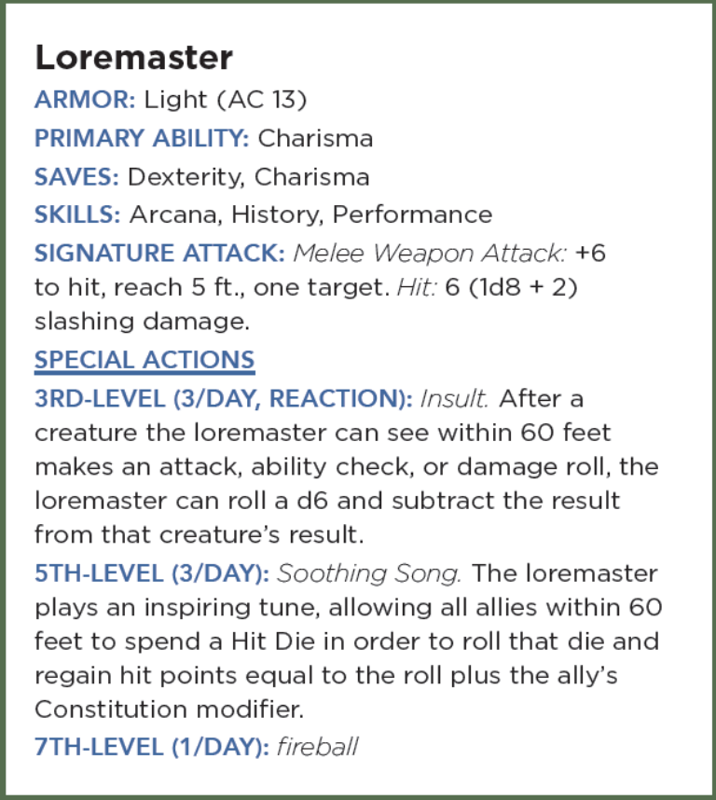

Fireball
3rd Level evocation
Casting Time: 1 action
Range: 150 feet
Components: V S M (A tiny ball of bat guano and sulfur)
Duration: Instantaneous

A bright streak flashes from your pointing finger to a point you choose within range and then blossoms with a low roar into an explosion of flame. Each creature in a 20-foot-radius sphere centered on that point must make a Dexterity saving throw. A target takes 8d6 fire damage on a failed save, or half as much damage on a successful one. The fire spreads around corners. It ignites flammable objects in the area that aren’t being worn or carried.
At Higher Levels: When you cast this spell using a spell slot of 4th level or higher, the damage increases by 1d6 for each slot level above 3rd.


Reeve Henriot
Male Human
Attack: +6
Saving Throws: +3 (+6 INT and WIS)
Skill Checks: +3 (+6 Arcana and Insight)
Spell Save DC: 13 (3rd), 14 (5th), 15 (7th)
Health: ⃝ ⃝ ⃝ ⃝ ⃝ ⃝ ⃝

