Volcanic Dagger
(Requires Attunement)
This magic dagger grants a +1 to attack and damage rolls, plus the damage from the dagger ignores fire resistance and causes maximum damage to inanimate objects and well as constructs.
As a reaction, the dagger can be commanded to absorb fire damage. Roll 3d8 to determine the amount of fire damage absorbed by the dagger. Any remaining damage is suffered as normal.
The dagger can't be used this way again until the next dawn.

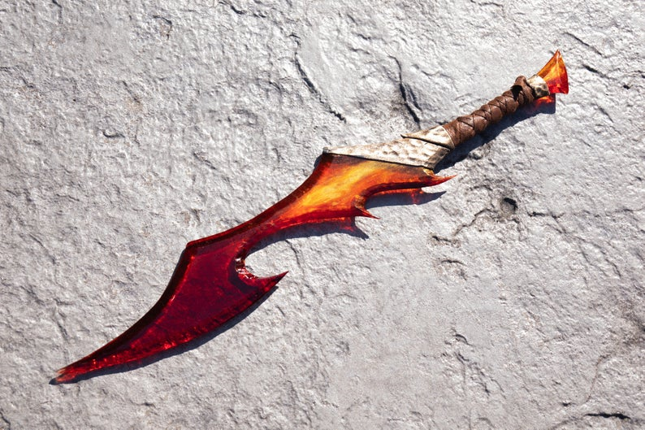

Belt of Ashes
(Requires Attunement)
This belt grants the wearer fire resistance.
As an action, you can cause the belt to smolder and release a cloud of ash and smoke that fills a 15ft cube centered on the belt for the duration of 1 minute. The smoke emanates from the belt and moves with it. The smoke spreads around corners.
A creature with Darkvision can’t see through this smoke, and nonmagical light can’t illuminate it but the wearer of the belt can see normally. If any of this smoke’s area overlaps with an area of light created by a spell of 2nd level or lower, the spell that created the light is dispelled.
The cloak can't be used this way again until the next dawn.
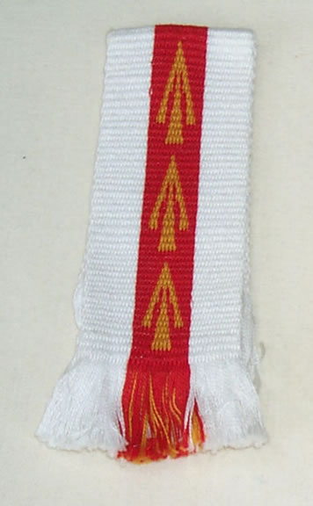

Phoenix Short Bow
(Requires Attunement)
This strange magic short bow has 2 bowstrings. The first bowstring grants the user +1 to attack and damage rolls. The second bowstring allows the wearer to fire an arrow up to 120 ft that blossoms with a low roar into an explosion of flame. Each creature in a 20-foot-radius sphere centered on that point must make a DC 15 Dexterity saving throw. A target takes 8d6 fire damage on a failed save, or half as much damage on a successful one. The fire spreads around corners and ignites flammable objects that aren’t being worn or carried.
The second bowstring burns away after use but reappears the next dawn.
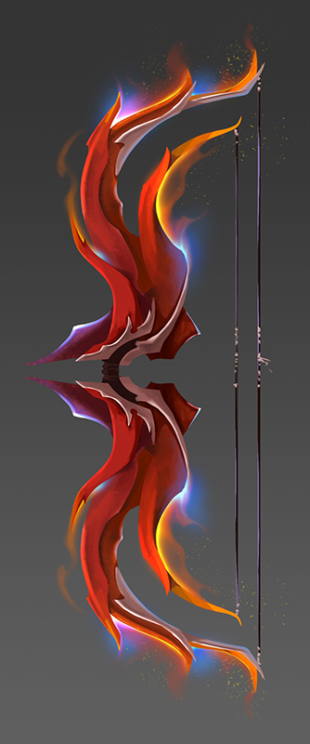
Red Dragon Scale Armor
(Requires Attunement)
This magical scale mail armor grants the user +1 to AC (AC 15 + Dex Mod, max 2) as well as Fire Resistance.
In addition, when hit with a melee attack, the wearer may use their reaction to cause the suit is burst into flames that burns the attacker. The creature must make a DC 15 Dex save. It suffers 3d10 fire damage on a failed save, or half as much damage on a successful save.
The armor can't be used this way again until the next dawn.

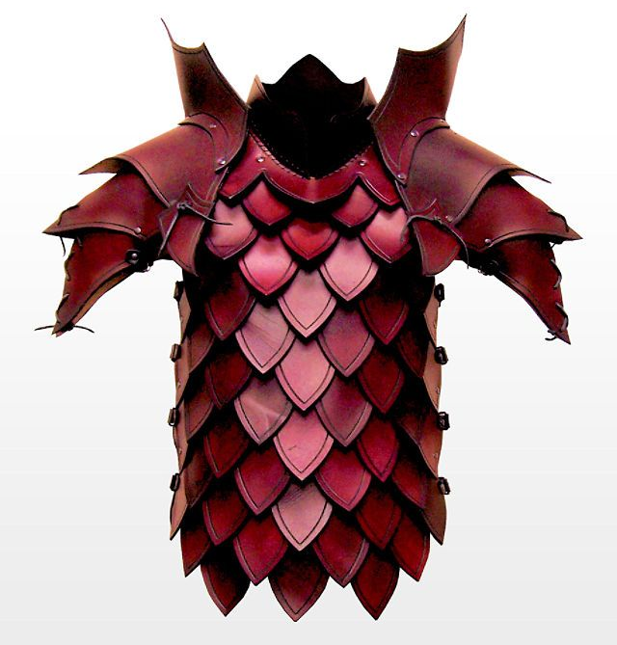

Staff of the Nine Hells
(Requires Attunement by a Druid, Sorcerer, Warlock, or Wizard)
You have Resistance to fire damage while you hold this staff.
The staff has 5 Charges. While holding it, you can use an action to expend 1 or more of its Charges to cast one of the following Spells from it, using your spell save DC: Burning Hands (1 charge) or Fireball (3 charges).
The staff regains 1d4 + 1 expended Charges daily at dawn. If you expend the last charge, roll a d20. On a 1, the staff blackens, crumbles into cinders, and is destroyed.

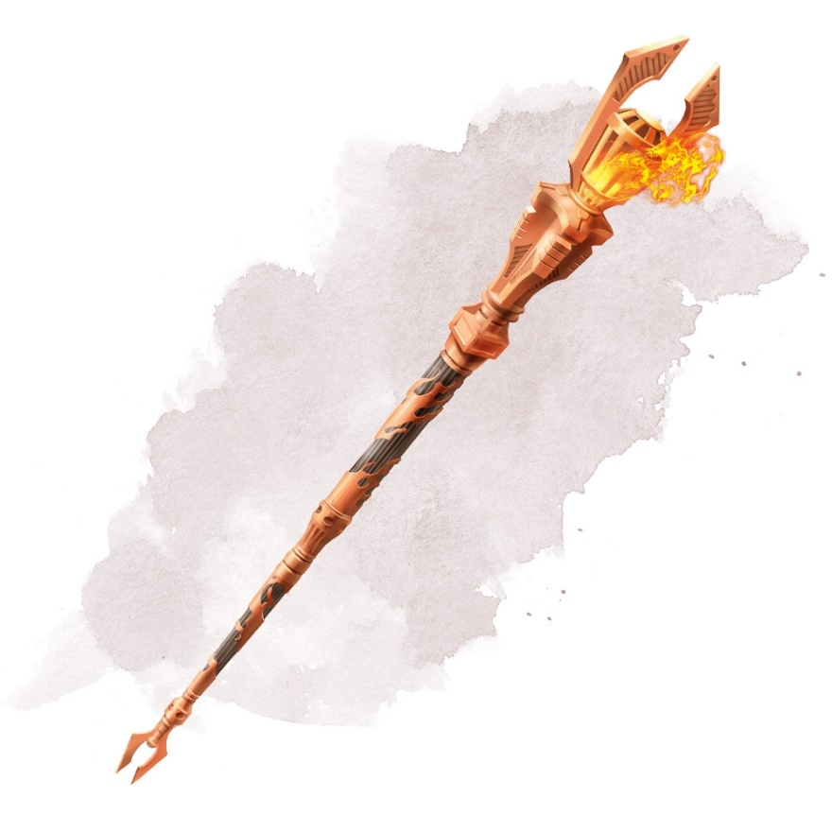
The Shield of Kossuth, the Fire Lord
(Requires Attunement by a Fighter or Paladin)
This magic shield provides a +1 to AC for anyone carrying this shield as well as Fire Resistance.
As an action, you can cause the shield to burst into flames for the duration of 1 minute. During the duration, any creature that misses a melee attack against the bearer of the shield takes 5 fire damage.
The shield can't be used this way again until the next dawn.
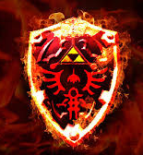
Cloak of Fiery Escape
(Requires Attunement)
The wearer of the cloak gains Fire Resistance.
You can use your action to teleport yourself to an unoccupied space you can see within 90 ft. Immediately after you disappear, there is a fiery explosion and each creature within 10 feet of the space you left must make a DC 15 Constitution saving throw, taking 3d10 fire damage on a failed save, or half as much damage on a successful one.
The cloak can't be used this way again until the next dawn.
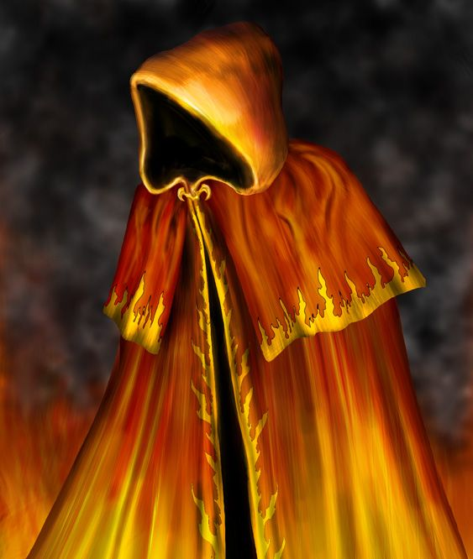

Aaron - Volcanic Dagger
Aiden - Belt of Ashes
Natasha - Phoenix Short Bow
Zack - The Shield of Kossuth, the Fire Lord
Elizabeth - Cloak of Fiery Escape
Brandon – Red Dragon Scale Armor
Devin - Staff of the Nine Hells

