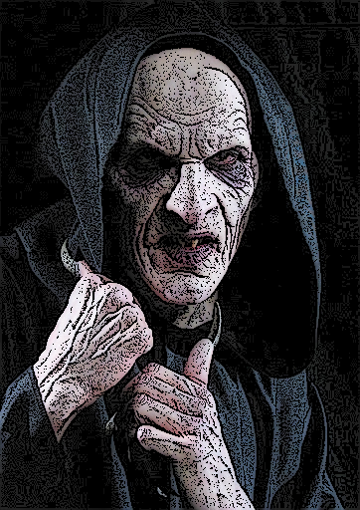
GREGORY
NOSFERATU

Gregory
- Was a bartender in Portland (Gregory Mills)
  - Good at making drinks and karaoke
- Turned by Janice (deceased)
- Fled after a Sabbat attack that killed a lot of vampires
- Contact (Criminal) – Manny Lopez
  - Uses personal info from Gregory to steal identities/credit card/money
  - Gives Gregory money for the info
  - Front operation is a small pawn shop (A-1 Pawn and Loans)
- Douglas Jones (Retainer)
  - Runs a comic shop (Fright House Comics)
  - Big horror fan
  - Believes all conspiracies
- Enjoys feeding on Meth heads (+1 die for rolls)
- Tommy Masters
  - Small boy who lives in the area
  - “Knows” Gregory is around (Imaginary friend)
  - Plays basketball – Gregory watches night games

Douglas Jones
average mortal
Attributes: Int 3, Wits 3, Composure 2, Charisma 2, Resolve2, and the rest at 1
Skills: Occult 3, Politics 3, Academics (History) 3, Finance 2, Larceny 2, Awareness 2, Investigation 2, Insight 1, Drive 1, Science 1, Technology 1, Persuasion 1
Advantages: Resources 2 (Comic Shop money)
Disciplines
Obfuscate
Level 1
Cloak of Shadows
Standing perfectly still, the user blends into the surroundings. If they have cover, make no sound, and don’t move, only mechanical or supernatural means can detect them.
Cost: Free
System: Follow the general rules for Obfuscate. The effect lasts until the user moves or they are detected by other means.
Duration: One scene

Level 2
Unseen Passage
With this power, the vampire can now move around while staying hidden. The user is functionally invisible, per the usual Obfuscate limitations.
- Cost: One Rouse Check
- System: If the user emits no overpowering odors and no sound louder than a whisper, this power automatically works. Only if the observer has their attention drawn to the user can they make a detection roll.
Sense the Unseen (Auspex 1) can also detect the hidden vampire, as per the general Obfuscate rules. (Wits or Resolve + Auspex vs Wits + Obfuscate)
Note that the user cannot use this power to disappear while being actively observed; it automatically fails in such a case.
- Duration: One scene or until detection

Potence
Level 1
lethal body
Using this power, the user is capable of causing horrendous damage to mortals, tearing skin and breaking bones with bare fingers.
- Cost: Free
- System: The user’s unarmed attacks can now do Aggravated Health damage to mortals, if desired. They also ignore one level of armor per Potence level of the user.
- Duration: Passive

soaring leap
Possessing unholy strength in more than arms and fists, the user can leap far higher and further than any mortal.
Cost: Free
System: The user can jump a number of meters equal to three times their Potence level vertically, and five times their Potence level horizontally. The user needs no run-up to make these leaps.
Duration: Passive

