
CHARLOTTE HILL
MALKAVIAN

Charlotte Hill
- Former Big Cat Vet for Seattle Zoo
  - Has haven under zoo
  - Appears spooky and ‘haunted’ – keeps mortal away
- Outspoken against Animal Testing Labs before death
  - Led protests against animal testing labs in Seattle
  - One lab hired thugs to ‘remove’ her from picture
- Turned vampire by Mad Mary
  - homeless cat lady
- Still has contact with current head of Big Cat Enclosure (Marcus)
  - Diana Coleman, friend/vet
  - Allison (Homeless Lady)
  - Famulus, Spots the Ocelot
- Farmer (avoids human blood when possible)
  - Hunts rodents like a cat

Disciplines

Obfuscate
Level 1
Cloak of Shadows
Standing perfectly still, the user blends into the surroundings. If they have cover, make no sound, and don’t move, only mechanical or supernatural means can detect them.
Cost: Free
System: Follow the general rules for Obfuscate. The effect lasts until the user moves or they are detected by other means.
Duration: One scene

Level 2
Unseen Passage
With this power, the vampire can now move around while staying hidden. The user is functionally invisible, per the usual Obfuscate limitations.
- Cost: One Rouse Check
- System: If the user emits no overpowering odors and no sound louder than a whisper, this power automatically works. Only if the observer has their attention drawn to the user can they make a detection roll.
Sense the Unseen (Auspex 1) can also detect the hidden vampire, as per the general Obfuscate rules. (Wits or Resolve + Auspex vs Wits + Obfuscate)
Note that the user cannot use this power to disappear while being actively observed; it automatically fails in such a case.
- Duration: One scene or until detection

Animalism
Level 1
Bond Famulus
When Blood Bonding an animal, the vampire can make it a famulus, forming a mental link with it and facilitating the use of other Animalism powers. While this power alone does not allow two-way communication with the animal, it can follow simple verbal instructions such as “stay” and “come here." It attacks in defense of itself and its master but cannot otherwise be persuaded to fight something it would not normally attack.
- Dice Pools: Charisma + Animal Ken
- Cost: The animal must be fed the user’s Blood on three separate nights, each of which requires a Rouse Check by the user. The amount of Blood needed to sustain the ghoul-state of the animal after this is negligible. Players starting with this power have completed this process and can chose a famulus for free.
- System: Without the use of Feral Whispers, below, giving commands to the animal requires a Charisma + Animal Ken roll (Difficulty 2); increase Difficulty for more complex orders. A vampire can only have one famulus but can get a new one if the current one dies. A vampire can use Feral Whispers (Animalism 2) and Subsume the Spirit (Animalism 4) on their famulus for free.
- Duration: Only death releases a famulus once bound. If it receives vampire Blood on a regular basis, the famulus does not age.

Dominate
Level 1
Cloud Memory
By uttering the phrase “Forget!” the user can make the Dominated victim forget the current moment as well as the last few minutes, enough to mask a superficial feeding or a chance meeting. No new memories are formed and if pressed the victim realizes they have a few minutes missing.
- Cost: Free
- Dice Pools: Charisma + Dominate vs Wits + Resolve
- System: No roll is required against an unprepared mortal victim. Clouding the memory of a resisting victim or another vampire requires a Charisma + Dominate vs Wits + Resolve roll.
- Duration: Indefinitely


Allison
weak mortal
- Attributes: Wits, Stamina at 2, the rest at 1
- Skills: Larceny, Survival, and Streetwise at 2, Awareness, Investigation, Brawl, Stealth, and Insight at 1
- Advantages: None

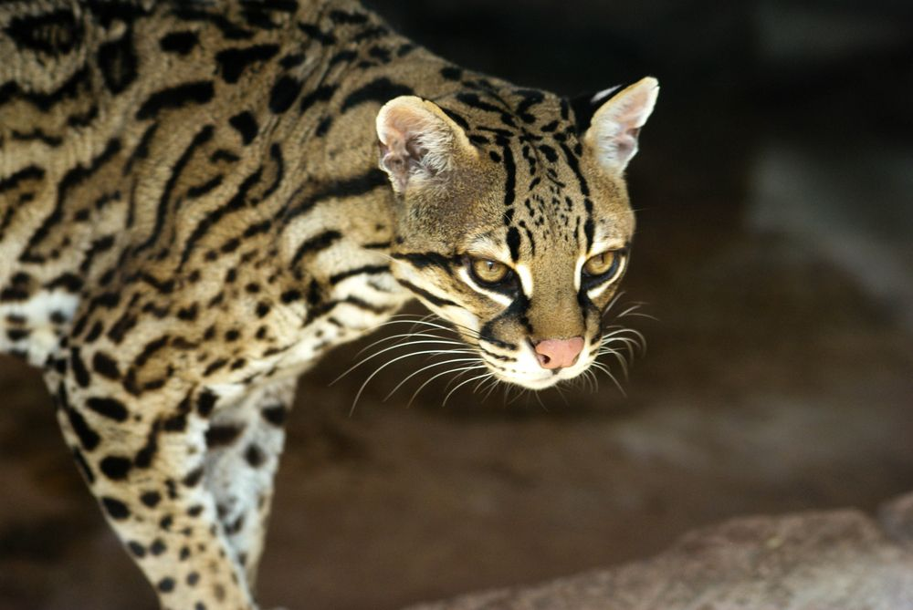
Spots the Ocelot
Standard Dice Pools: Physical 5, Social 1, Mental 1
Secondary Attributes: Health 5, Willpower 2
Exceptional Dice Pools: Awareness 4, Brawl 6, Intimidation 4, Stealth 4
Special: Add +1 to damage done by ocelot bites

