Setup:
IRON MAN IS BORN!
This Power Legions playthrough is based on a fight scene in the cartoon The Avengers: Earth’s Mightiest Heroes Episode 1: Iron Man is Born!
The play area is 30” x 30” with buildings, cars, and random scatter placed on the board. There is a crater in the street where the robots will be starting.
HYDRA is attacking the UN building in NYC. Iron Man shows up and dispatches the HYDRA soldiers. There is a blast and three HYDRA robots emerge from a hole in the street.
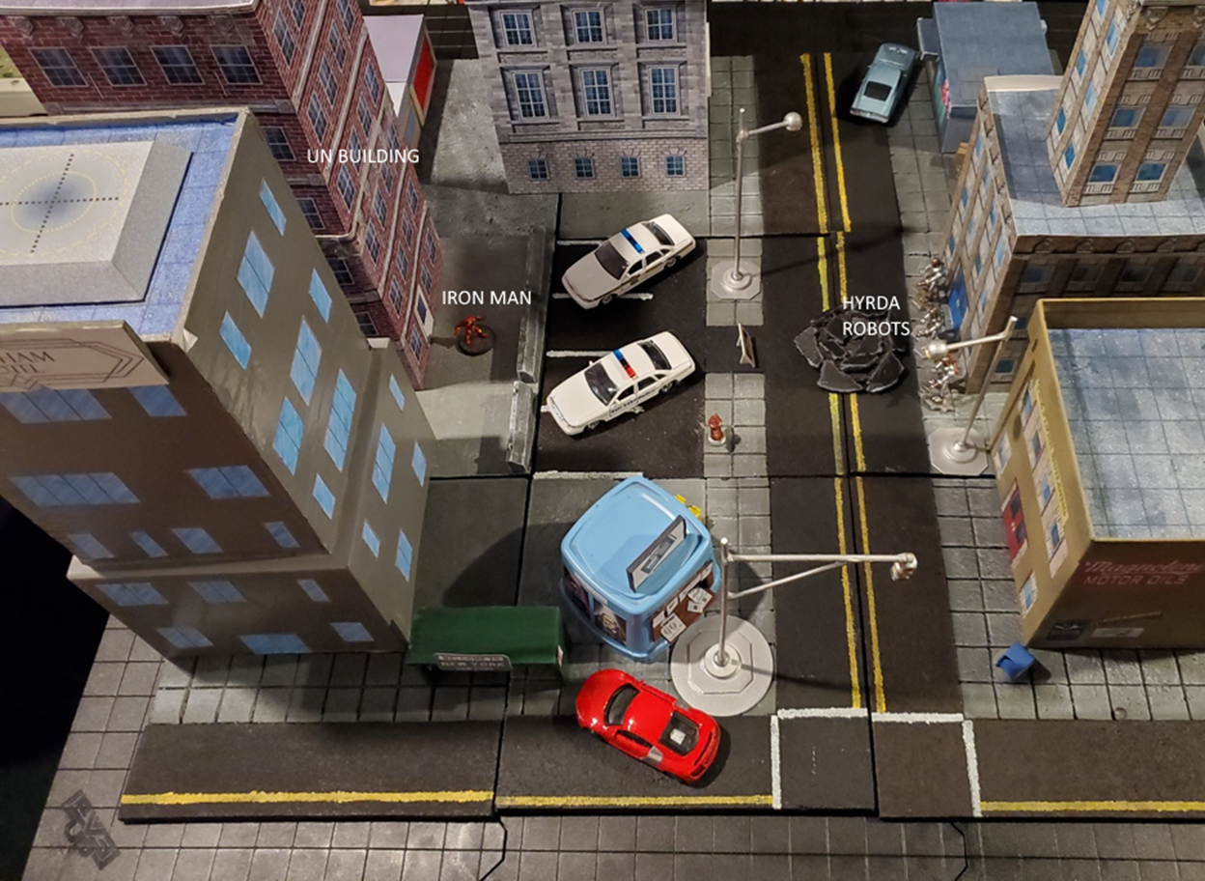
Starting Board
Name: Iron Man (Tony Stark) |  | Points: 932
Mind: d10 | Agility: d8 | Strength: d10 | Knockout: d12
Damage Resistance: d12+5 |  | Activation: d10
Powers and Tricks:
Armor d10, Flight d12, Ranged Damage d10, Flare d10, Combat Computer, Sealed Armor, Immune to Flare, Night Vision, Boost

Name: Killer Robot |  | Points: 502
Mind: d6 | Agility: d6 | Strength: d10 | Knockout: d10
Damage Resistance: d10+4 |  | Activation: d6
Powers and Tricks: Artificial, Armor d8, Ranged Damage d10

There are three (3) killer robots: Red, Green, Blue (Each named for the color of the pack on their back.)
Initiative:
Iron Man 2, Robots 5 Robots will go 1st

Round 1
Red Robot rolls 2 actions. 1st action is move towards Iron Man. 2nd action is shooting. Red hit but there is no damage.
Green Robot rolls 1 action and moves to Iron Man.
Blue Robot rolls 3 actions. 1st action is move towards Iron Man. 2nd action is shoot, miss. 3rd action is shoot, miss!
Iron Man rolls 1 action. He uses Combat Computer against Red Robot.
From the dust of the impact rushes out three HYDRA robots. The first robot fires a beam from his arm cannon. It strikes Iron Man, but his armor deflects the energy from the blast. The third robot fires two additional beams at Iron Man, but he dodges the blasts.
“Watch it! You almost scratched the suit! Jarvis, lock onto that robot that hit me. HYDRA needs to pay for that!” The computer voice of Jarvis simply replies “Yes sir. Robot has been targeted and tactics analyzed.”
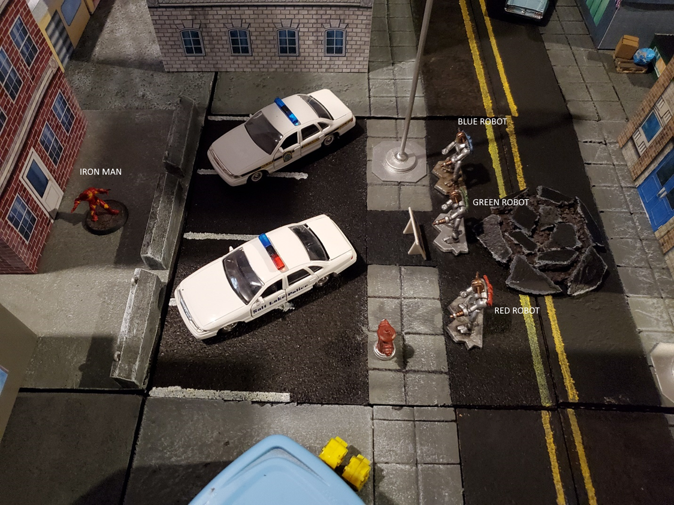
End of Round 1
Status:
IRON MAN:
BLUE ROBOT:
GREEN ROBOT:
RED ROBOT:

Round 2
Red Robot rolls 3 actions. 1st action – move to police car. 2nd action – pick up police car. 3rd action – throw police car at Iron Man. Red robot misses and police car smashing into building.
Green Robot rolls 1 action and shoots at Iron Man but misses.
Blue Robot rolls 3 actions. 1st action – move towards Iron Man. 2nd action is to move into melee with Iron Man. 3rd action to attack Iron Man. Blue Robot wins the fight but does no damage.
Iron Man rolls 2 actions. 1st action is melee attack against Blue Robot. Blue robot wins and does a minor damage. Iron Man gets knocked down. 2nd action is to stand up.
The Red robot strides toward a parked police car. It lifts the car over its head and hurls it at Iron Man, who ducks below the flying vehicle. The car continues and smashes into the front of the UN building. The Green Robot steadies his arm cannon at Iron Man and fires a blast, but it goes wide. The Blue Robot closes with Iron Man. It swings a huge metal arm down at the armored man, but Iron Man holds up his own arms to stop it.
“Is that the best you got? You have to try harder than that if you want to beat …” Before Tony could finish his sentence, the Blue Robot had brought its second arm down on top of him, driving him into the concrete. The robot pulls back its arms and attempts to stomp on the prone opponent, but Iron Man rolls out of the way and to his feet.

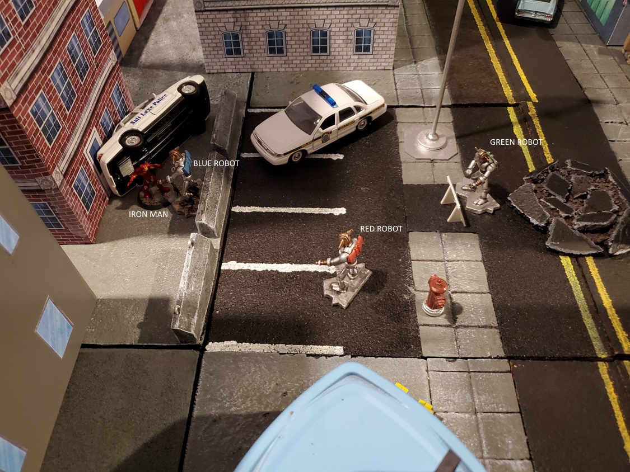
End of Round 2
Status:
IRON MAN:
BLUE ROBOT:
GREEN ROBOT:
RED ROBOT:

Round 3
Red Robot rolls 2 actions. 1st action is to move towards Iron Man. 2nd action is a melee attack. Red Robot hits and scores a knockdown.
Green Robot rolls 2 actions. 1st and 2nd actions are move towards Iron Man.
Blue Robot rolls 2 actions. It spends both actions to do a Power Blow. It hits and applies a Reeling condition to Iron Man. (Any melee attacks you perform are at -1 on Agility until you use two actions to recover. Ranged attacks are unaffected.)
Iron Man rolls 1 action. 1st attack to stand up.
The robots press the attack. The red robot moves into melee range with Iron Man, grabs him by the head, and slams him into the ground. The green robot takes this opportunity to close in with Tony as the blue robot slams both arms down on Iron Man. Tony yells out as the impact cracks the screen in his HUD.
After the blow, Tony staggers to his feet. “Jarvis, remind me to take a long vacation after I handle these tin cans.”
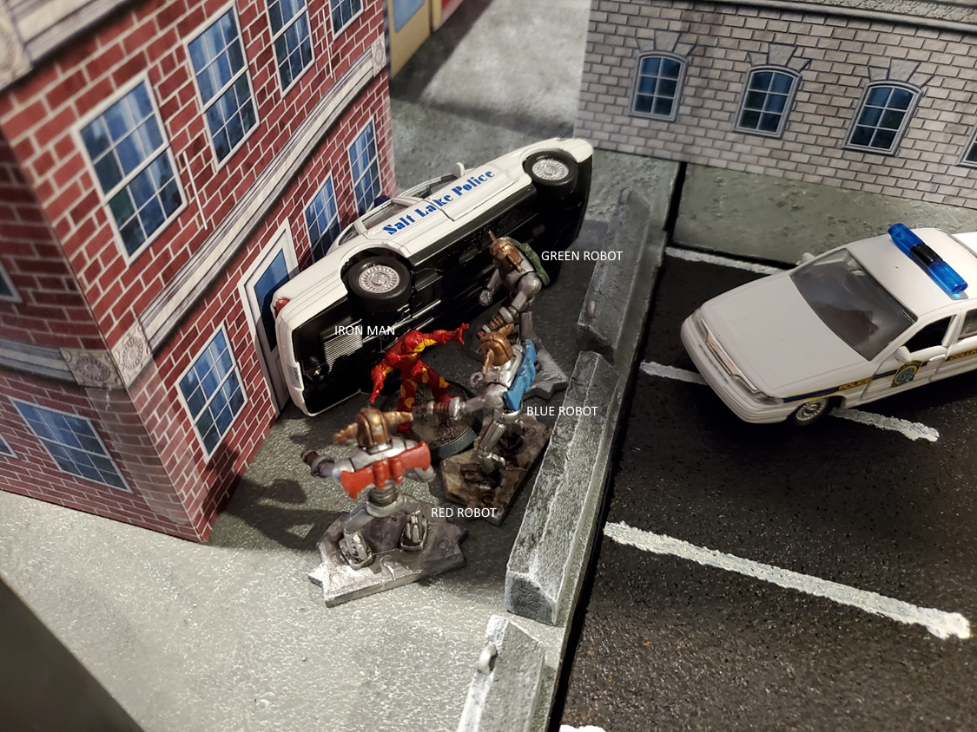
End of Round 3
Status:
IRON MAN: Reeling
BLUE ROBOT:
GREEN ROBOT:
RED ROBOT:

Round 4
Red Robot rolls 2 actions. It uses both to perform Power Blow. The robot hits but fails to do damage.
Green Robot rolls 3 actions. It uses 2 actions to perform Power Blow. Robot wins but don’t do damage. 3rd action is a melee attack. Iron Man wins and does Major Damage to the robot and selects Staggering (d4) condition (At the beginning of any of your turns, make a Knockout roll vs. d4 or be KO. If you receive another stagger effect, increase the stagger die by one die type.).
Blue Robot rolls a turnover!
Iron Man rolls a turnover as well!
The robots continue to pummel the armored Avenger but just do superficial damage to his armor. While doing his best to defend himself, Tony spots an opening in the green robot’s defense. He delivers an uppercut to the robot’s head, splitting open the faceplate and showering the area in sparks.
“Good shot sir” Jarvis remarks. “Thanks, but why don’t use help figure a way out of this instead of just complimenting me.” Tony replied to his AI friend.

End of Round 4
Status:
IRON MAN: Reeling
BLUE ROBOT:
GREEN ROBOT: Staggering(D4)
RED ROBOT:

Round 5
Red Robot rolls 2 actions. Both actions for Power Blow. Red Robot wins but no damage.
Blue Robot rolls 2 actions. Both actions for Power Blow. Blue Robot wins and score a knockback (2xL). Iron Man is sent back across the street where the robot emerged. He lands prone.
Green Robot passes its Knockout roll. Green Robot rolls 2 actions. 1st action is to move the car out of the way. 2nd action is to attack the UN building, scoring minor damage to the front of the building.
Iron Man rolls 2 actions. First action is to stand up. 2nd action is shoot Red Robot. Iron Man uses his Boost Power to the damage to d12. Iron hits and scores a Direct Hit. Red Robot fails its save and is KO.
The Red Robot continues its physical assault against Iron Man who does his best to block all the incoming blows. Just then, the Blue Robot grabs Iron Man and throws him across the street where he lands on his back. Green Robot, with its sparking head, shoves the police car out of the way and begins firing its arm cannon into the front of the UN building, destroying the front doors and lobby windows.
Iron Man pulls himself back to his feet. “Jarvis, route all available power through to the Uni-Beam.” The light on the front of the chest plate glows brightly then fires a brilliant beam across the street and into the torso of the Red Robot, burning a hole completely through the robot. Red Robot collapses to the parking lot and explodes in a shower of small parts. “That’s one down!”

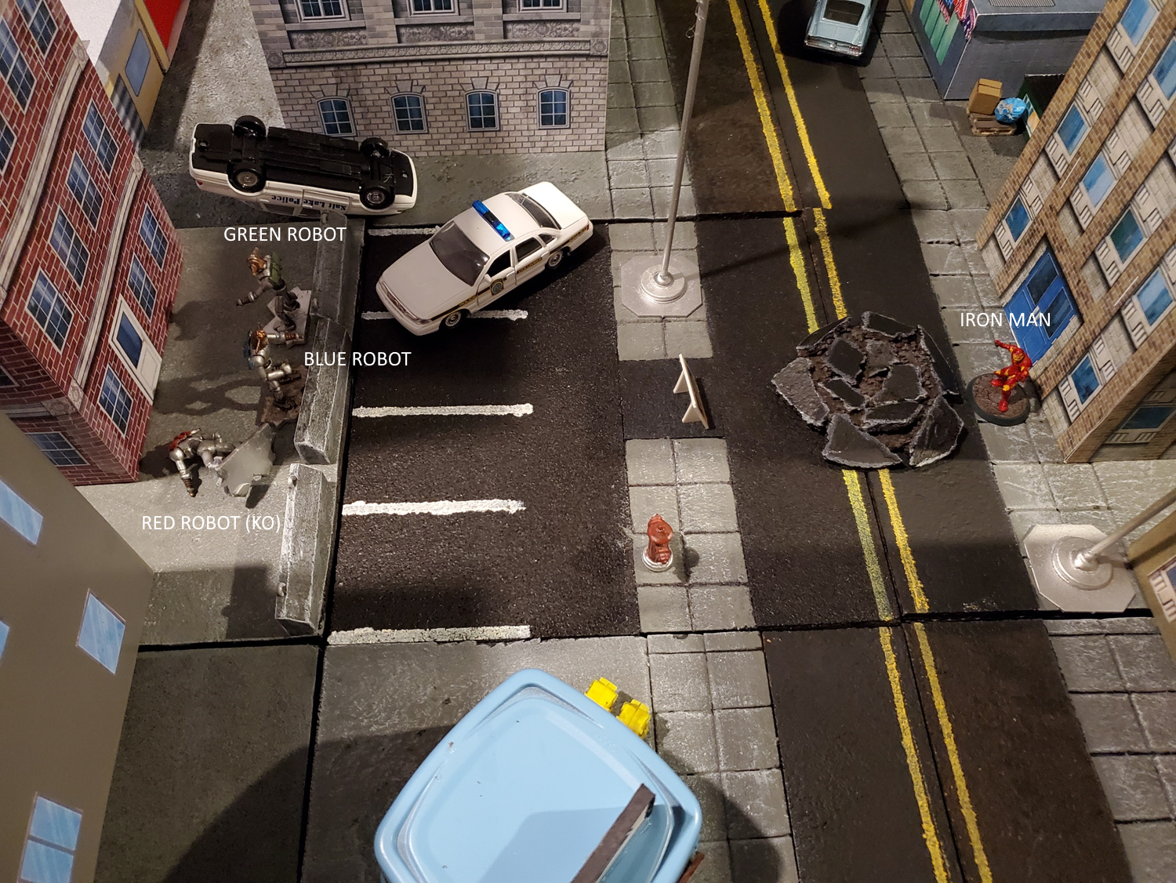
End of Round 5
Status:
IRON MAN: Reeling
BLUE ROBOT:
GREEN ROBOT: Staggering (d4)
RED ROBOT: KO!
DIRECT HIT (Minor Effect): You must make a Knockout roll vs. the damage that hit you. If you fail, you are KO’d. This effect may be chosen only if the damage is equal to or better than the target’s Knockout attribute.

Round 6
Blue Robot rolls 2 actions. It uses both actions for a Aimed Shot at Iron Man, but misses.
Green Robot fails its Knockdown roll is and is out of the fight (KO).
Iron Man rolls 1 action. He uses Flight to attempt to slam into Blue Robot. Iron Man hits and Blue Robot is prone.
Blue Robot levels its arm cannon at Iron Man and fires a blast. Tony ducks the blow which damages the building behind him. The Green Robot begins to turn to face the Avenger but the head sparks and explodes! The rest of the robot falls to the ground.
“Well, look at that. HYDRA quality at its finest.” His rocket boots ignite and Iron Man flies directing into Green Robot, knocking it to the ground.

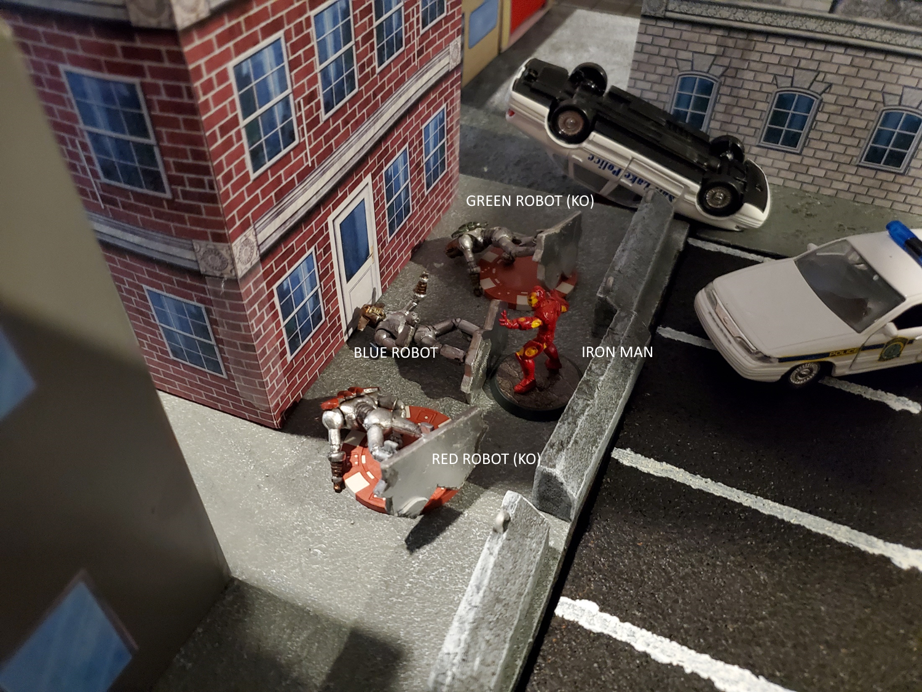
End of Round 6
Status:
IRON MAN: Reeling
BLUE ROBOT: Prone
GREEN ROBOT: KO! (Poker Chip to show KO effect)
RED ROBOT: KO! (Poker Chip to show KO effect)

Round 7
Blue Robot rolls 1 action. 1st action to shoot Iron Man. Hits but no damage!
Iron Man rolls another turnover!
“You should just stay down you piece of junk.” Iron Man stands over the prone Blue Robot. It raises an arm and fires a blast into Iron Man’s face, causing him to take a step back. This gives the robot a chance to get back to his feet.

End of Round 7
Status:
IRON MAN: Reeling
BLUE ROBOT: Prone
GREEN ROBOT: KO! (Poker Chip to show KO effect)
RED ROBOT: KO! (Poker Chip to show KO effect)

Round 8
Blue Robot rolls 2 actions. 1st action to stand up. 2nd action to attack Iron Man. Tie roll so both hit but neither do damage.
Iron Man rolls 3 actions. 1st action is to change the Combat Computer to Blue Robot. 2nd and 3rd action for Power Blow. Robot wins the attack but does no damage.
Both combatants attack at the same time, their fists colliding in midarm with a loud clang! “Block this!” Iron Man bring both arms down on the robot in an ax handle attack but the Blue Robot punches Iron Man in the chest before he can land his blow.
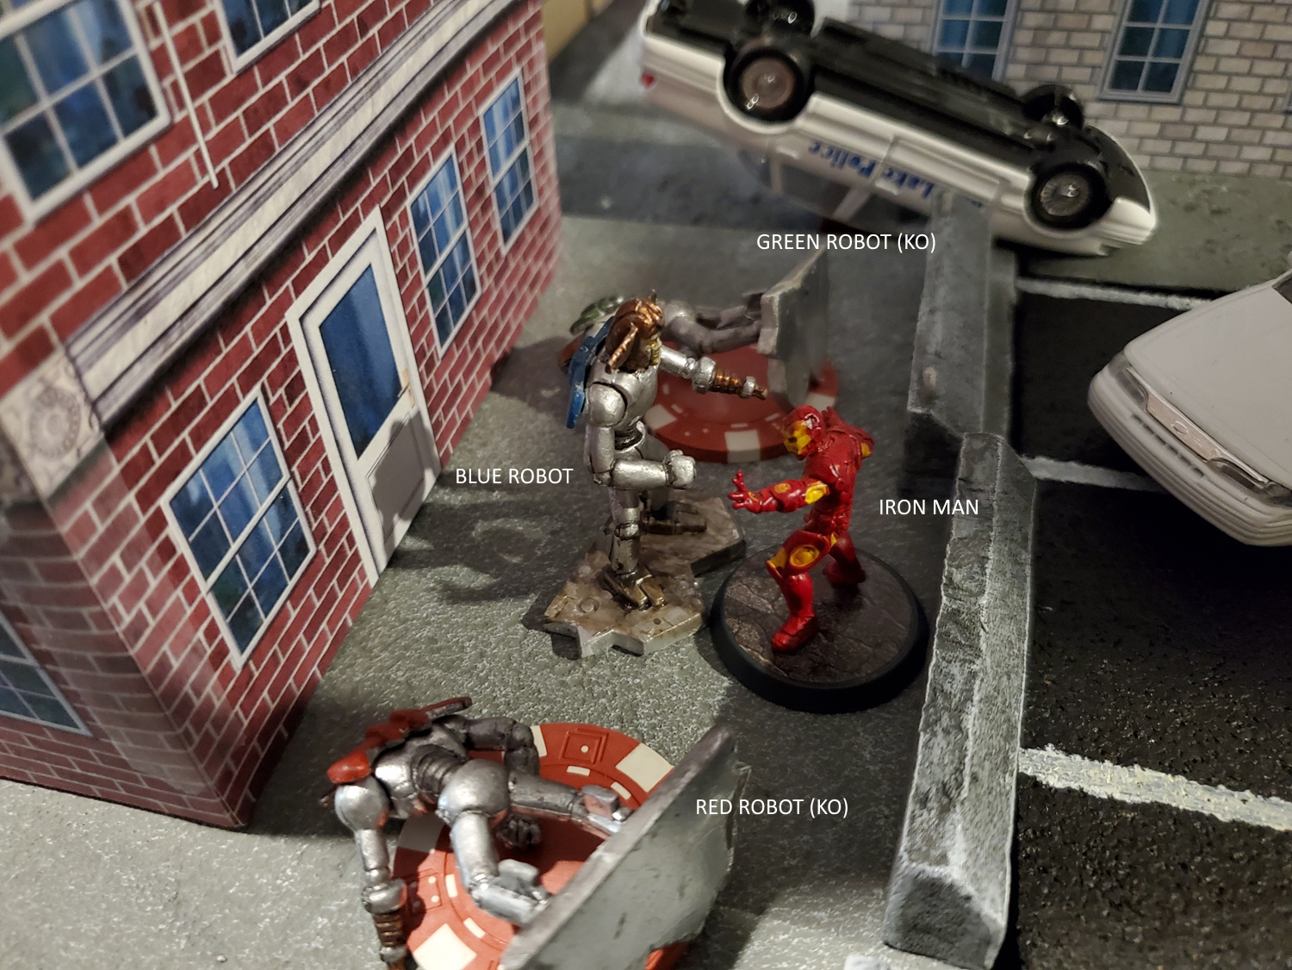
End of Round 8
Status:
IRON MAN: Reeling
BLUE ROBOT:
GREEN ROBOT: KO! (Poker Chip to show KO effect)
RED ROBOT: KO! (Poker Chip to show KO effect)

Round 9
Blue Robot rolls 1 action. It attacks Iron Man, hits, but no damage.
Iron Man rolls 3 actions. 1st action is a flight. Blue Robot takes a Free Hack but hits. 2nd and 3rd actions are an Aimed Shot at Blue Robot. He hits but no damage to the Blue Robot.
The Blue Robot swings again at Iron Man, but he dodges the blow and flies to the top of the newsstand. As he lands on the roof of the building, Iron Man fires his repulsors at the robot. The robot uses its arms as a shield and blows the damaging blast.
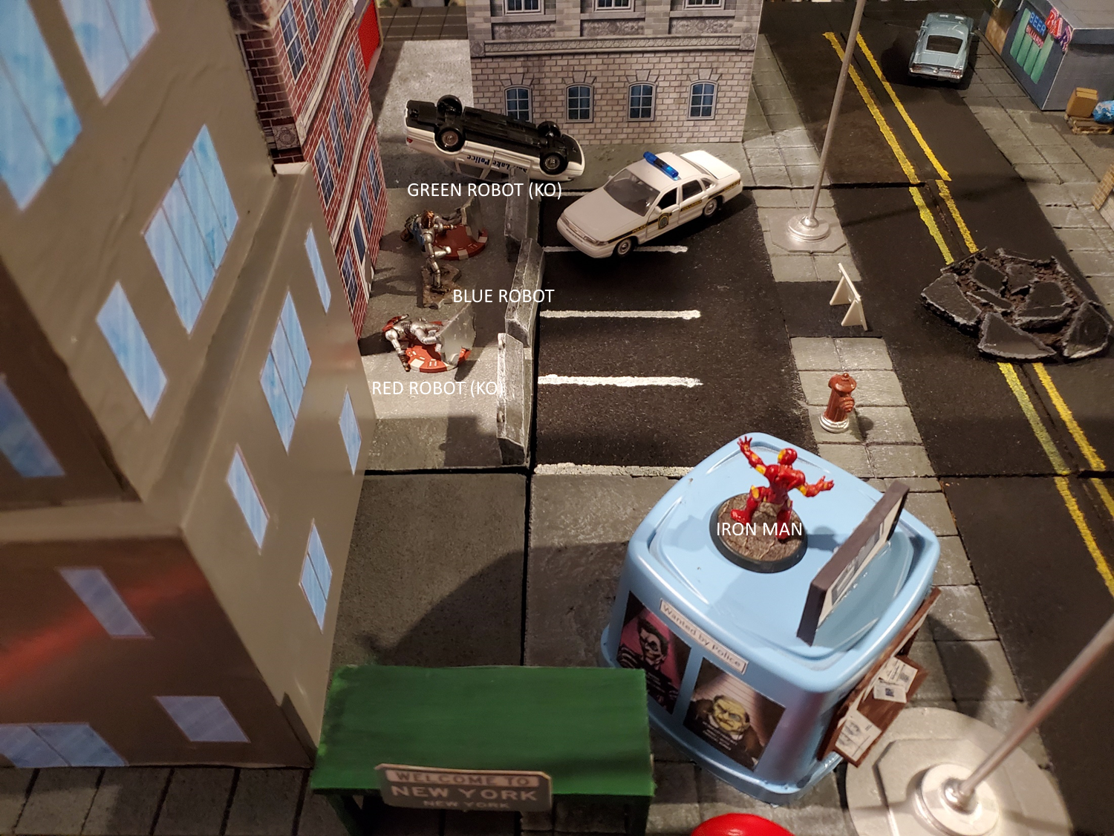
End of Round 9
Status:
IRON MAN: Reeling
BLUE ROBOT:
GREEN ROBOT: KO! (Poker Chip to show KO effect)
RED ROBOT: KO! (Poker Chip to show KO effect)

Round 10
Blue Robot rolls 3 actions. 1st action is a move towards Iron Man to close the range. 2nd and 3rd actions are an Aimed Shot. The robot hits Iron Man and chooses Direct Hit. Iron Man fails his save and he is KO’d!
The blue robot walks towards Iron Man while steading its arm cannon at the hero. A blast sails from the cannon and strikes Iron Man in the chest, sending him to his back. Inside the head, everything goes black, except for a little timer in the corner of view that is counting down to zero with the words REBOOT TIME REMAINING.
“Forget this.” Tony lifts the visor from his helmet and tries to spot the blue robot. Just then, a blinding light blast comes down from the sky and the Blue Robot explodes! As Iron Man looks up from his back, he can see the SHIELD Helicarrier floating over the city with SHIELD agents flying into the area with jet packs.
“About time you guys got here. I had everything under control, but thanks for the assist.” As the timer reaches zero, the lights on the armor turn on and Iron Man climbs to his feet. He takes to the air and flies up to meet the SHIELD agents as they decend. “By the way, tell the guys in the U.N. ‘You’re welcome’ when you see them”. With that, Iron Man flies over New York.
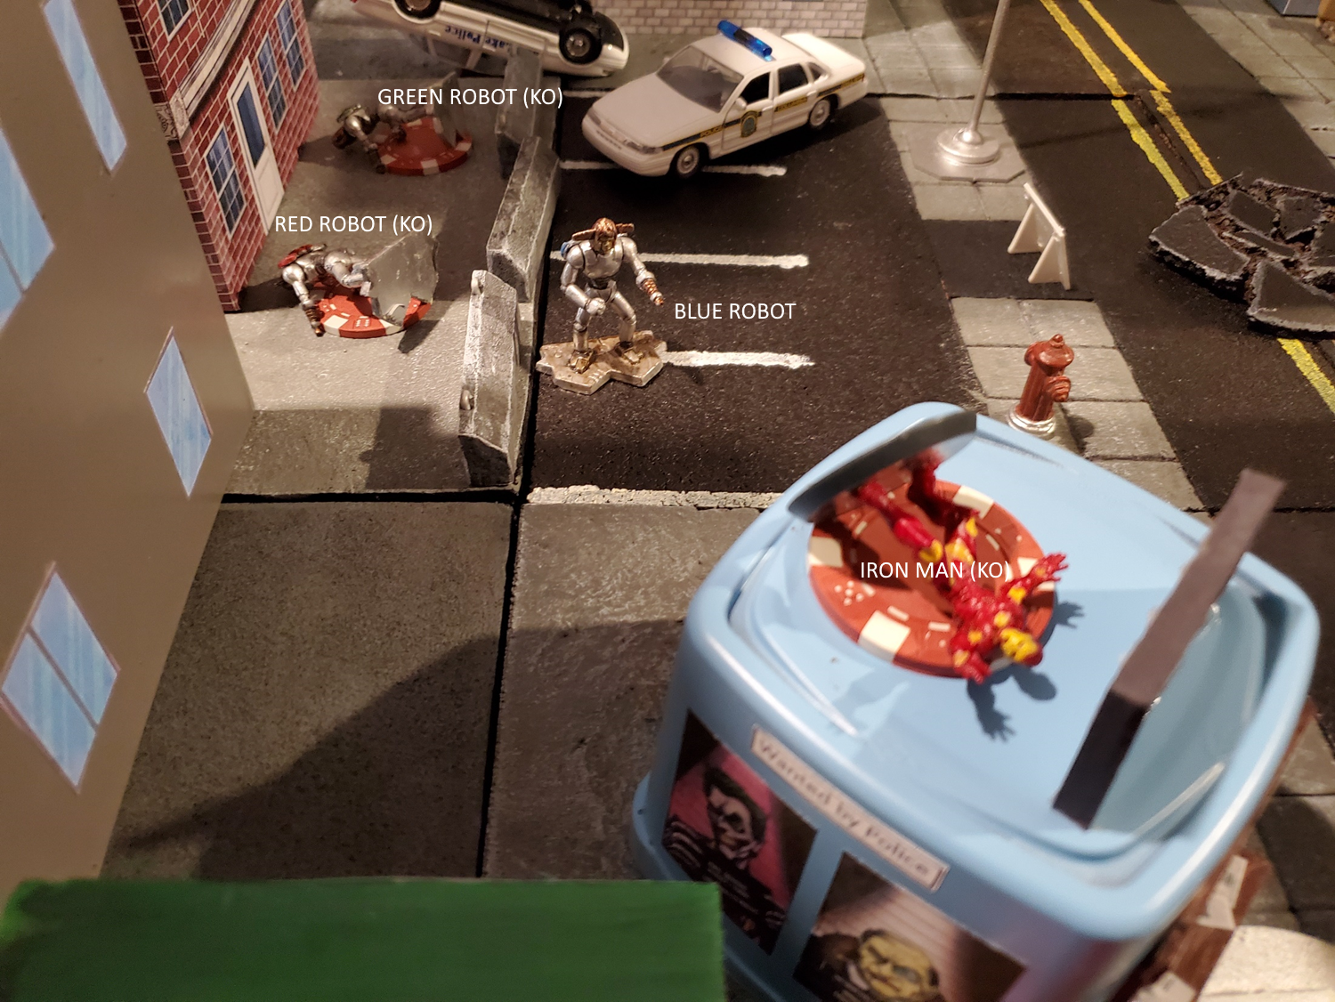
End of Round 10
Status:
IRON MAN: Reeling, KO!
BLUE ROBOT:
GREEN ROBOT: KO!
RED ROBOT: KO!

Final Thoughts
The fight went well and almost the same as the cartoon. Iron Man is hard to hurt (which is why he is called the Invincible Iron Man). The robots did good for what they are, minions.
Next, I am going to run the fight between Thor and the Wrecking Crew!

